Project Report: Walmart Retail Customer Retention Analytics Using Power Bi

Video Link-
https://share.vidyard.com/watch/3vWGow6BCqiedi8h32FuvB?&vyetoken=7ef950fe-afdd-484c-a670-ae84207cd9bc

Task 1: Data Modeling & Cleaning (10 Marks)
Steps Used
1. Loaded all five CSV files into Power Query editor.
2. Removed duplicate rows and capitalized each word & trimmed and cleaned the row.
3.Extraced transaction month and year from transaction date in customer transaction data.
4.Convert Data types: Dates-Date and amount – decimal and whole number to other column like points earned and redeemed.
5. Calculated Columns Created in customer demographic table from using the formula- screenshot attached
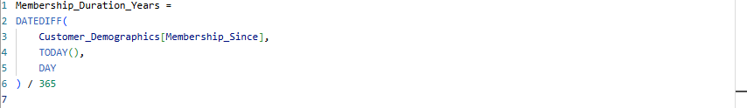

6. Data Model Designed (Star Schema)

One-to-Many: Customer_Demographics → Transactions, Loyalty_Program,
Churn_Labelled_Customers
Many-to-One: Transactions → Store_Locations

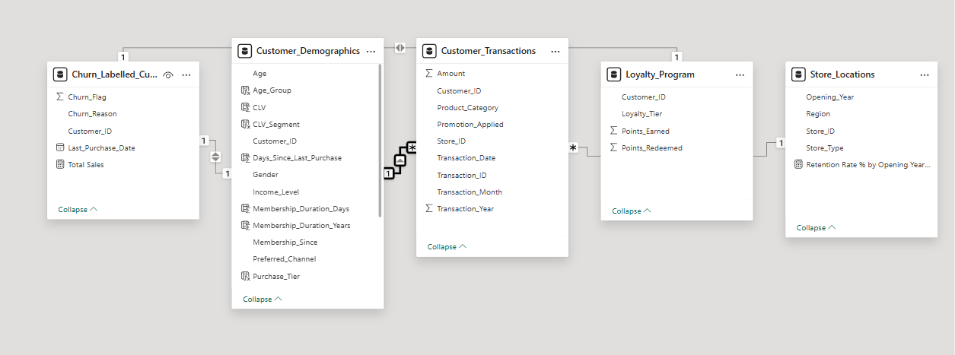

Task 2: Churn & Retention Metrics (10 Marks)
Steps Used
1.create new table called churn metric and calculate the below Dax Measure
1.Churned Customer 2. Total Customer 3. Retention Rate% 4. Active Customer
5.Churn rate%

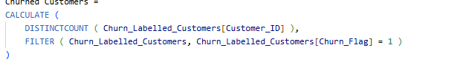
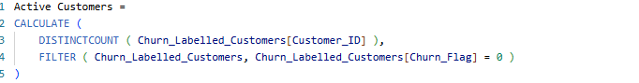
2.Create card visualization tool and visualize the below

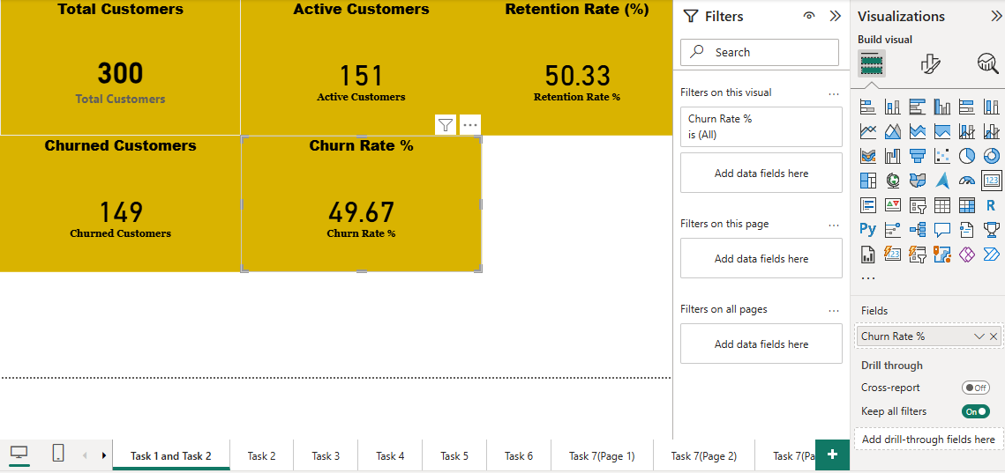

3. Visuals Created-Churn Rate by Region, Churn by Income Level, Churn by Channel (Store vs Online), Churn Rate by Loyalty Tier, Customer Funnel (Total - Repeat - Churned)

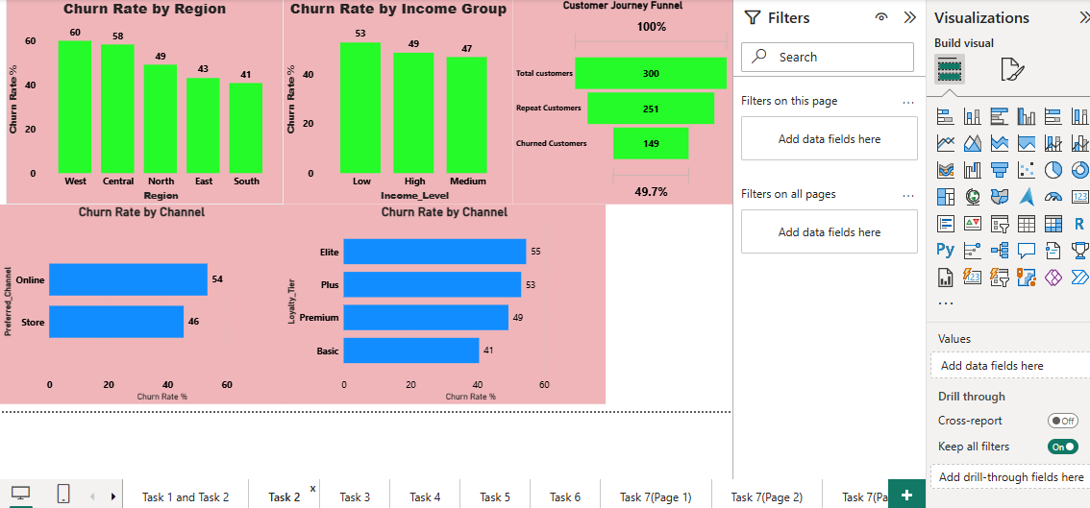

Insight and Recommendations

1. Almost half of customers churn-Poor retention and West region has serious churn problems.
2. Prioritize retention of high-value and at-risk groups and online churn 54% so focus on improving App/website experience, Delivery speed, Chat support and order tracking
3. Improve Loyalty Program Engagement like More rewards for repeat purchases and Personalized communication via app/SMS.

Task 3: Repeat Purchase Analysis (10 Marks)

Steps Used

1.create a new calculated column and use the formula = Total_Purchases = COUNTROWS (RELATEDTABLE(Customer_Transactions)) it will show Count Total Purchases per Customer id
2.create new calculated column and find the Segment customers to use the below Dax:
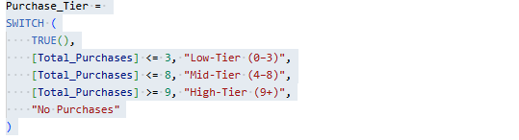

So customers are classified into:
- Low Tier (0–3 purchases)
- Mid-Tier (4–8 purchases)
- High Tier (9+ purchases)
- If no purchase → “No Purchases”

3.Create New measure to calculate Avg Purchase Frequency = AVERAGE ( Customer_Demographics[Total_Purchases] )
4. Calculated new column for age group segmentation

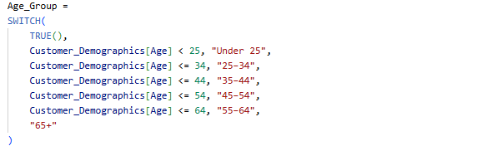
5.Calculted New Dax measure for most purchased category-“High Tier”

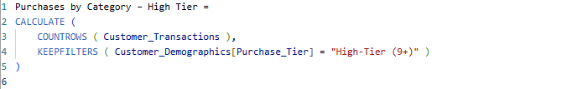

6.Visualize segment customer and Compare avg. purchase frequency by Region, Age Group, Loyalty Tier and Identify most purchased product categories by loyal customers.

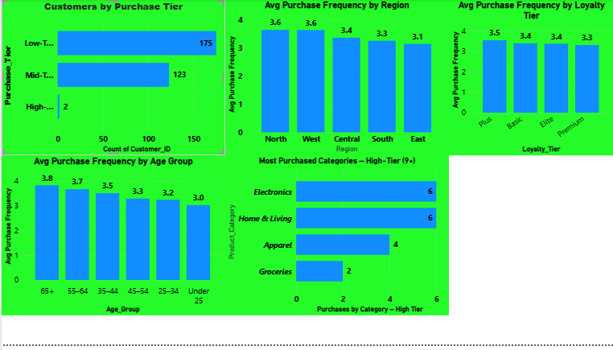

Insight and Recommendations

- Majority of customers fall in the Low (0–3) and Mid (4–8) purchase tiers, with only a very small number qualifying as High-Tier (9+) loyal customers.
- North and West regions show the highest repeat purchase frequency, while East has the weakest repeat behaviour.
- Older age groups (55+ and 65+) demonstrate stronger repeat behaviour, whereas younger customers (Under 25) shop less frequently.
- High-Tier (9+) loyal customers primarily purchase Electronics and Home & Living, with less focus on Groceries.
- Youth-focused offers (student discounts, app-based coupons) to target the younger customer.
- Localized marketing to improve engagement where repeat frequency is low and Region-specific promotions for East/South.

Task 4: Promotion & Loyalty Impact (10 Marks)

Steps Used

1.Create new table called Promo_Loyalty_Measures
Calculate % Promo Transaction using the Dax formula -% Promo Transactions = DIVIDE([Promo Transactions], [Total Transactions] ) * 100

2. compare Avg Purchase Amount (With vs Without Promotion) using the DAX

Avg Amount (All) = AVERAGE(Customer Transactions[Amount] )

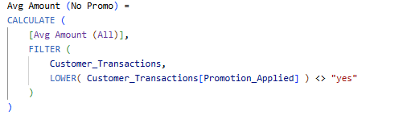
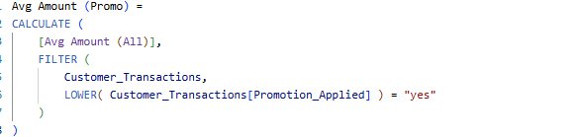

3. To visualize this, create a new table using the Dax measure

Promo Flag = DATATABLE ("Promo Flag", STRING, { {"Promo"}, {"No Promo"} })
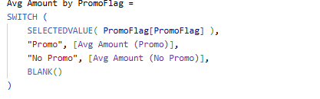
4.Create a new measure to calculate points earned vs redeemed

Points Earned = SUM( Loyalty_Program[Points_Earned] )
Points Redeemed = SUM( Loyalty_Program[Points_Redeemed] )
5. Create a below visual

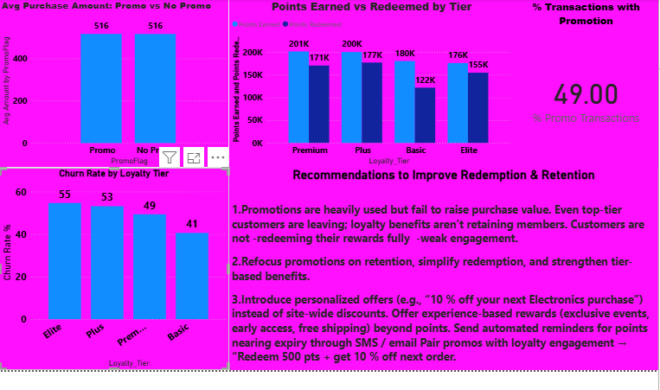

Insight and Recommendations

1.Promotions are heavily used but fail to raise purchase value. Even top-tier customers are leaving; loyalty benefits aren’t retaining members. Customers are not -redeeming their rewards fully weak engagement.

2.Refocus promotions on retention, simplify redemption, and strengthen tier-based benefits.

3.Introduce personalized offers (e.g., “10 % off your next Electronics purchase”) instead of site-wide discounts. Offer experience-based rewards (exclusive events, early access, free shipping) beyond points. Send automated reminders for points nearing expiry through SMS / email Pair promos with loyalty engagement - “Redeem 500 pts + get 10 % off next order.

Task 5: Store & Channel Performance vs Retention (10 Marks)

Steps Used
1.Create a new table called Store channel measure and create new measure

2. To calculate how many churned customers belong to each Store Type use the Dax measure

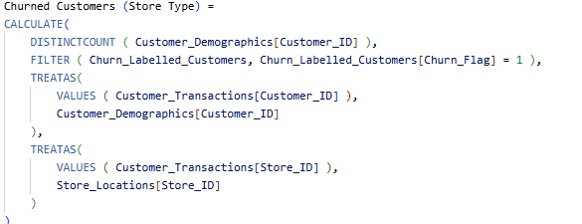

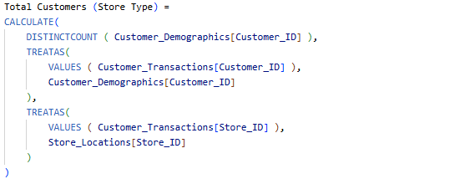

3.Create below visual avg amount by store type,churn rate by store type and retentation rate % by opening year.

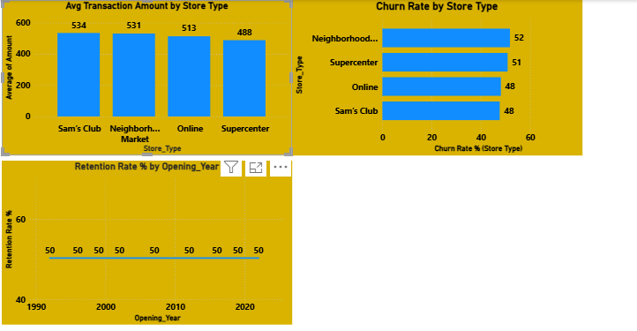

Insight and Recommendations
- Sam’s Club customers show stronger purchasing power.
- Online performance is better than expected, indicating stable digital customers.
- Neighborhood Market shows the highest churn (52%)
- Strengthen customer experience in Neighborhood Market stores
- Promote memberships, expand product variety, and introduce premium services
- Focus on store-type optimization, not store-age upgrades

Task 6: Customer Lifetime Value (CLV) Analysis (10 Marks)

Steps Used

1. In the Customer_Demographics table, Create a calculated column and used Dax Membership_Duration_Years =
DIVIDE (Customer_Demographics[Membership_Duration_Days], 365)
2.Calculated new column total spent using below Dax measure

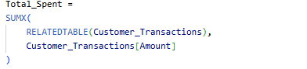
3. Calculated Customer Lifetime Value (CLV)=

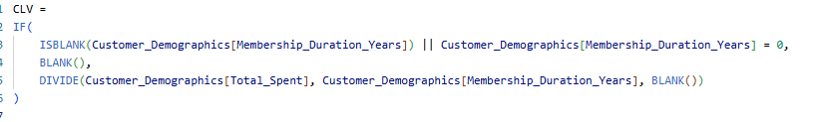

4. Segmented Customers into High and Low CLV

1. Average_CLV = AVERAGE(Customer_Demographics[CLV])
2. 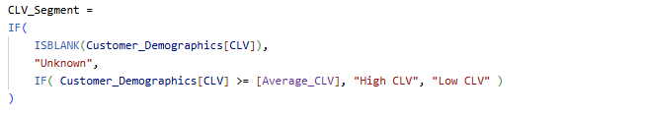
5. calculated Days since last purchase=

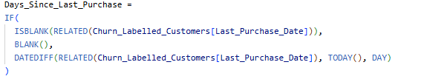

6.Created Below Visual CLV vs Days Since Last Purchase, CLV by Loyalty Tier & Region, Top 10 Average CLV Customers and add slicer on basis of Loyalty tier region and CLV segment
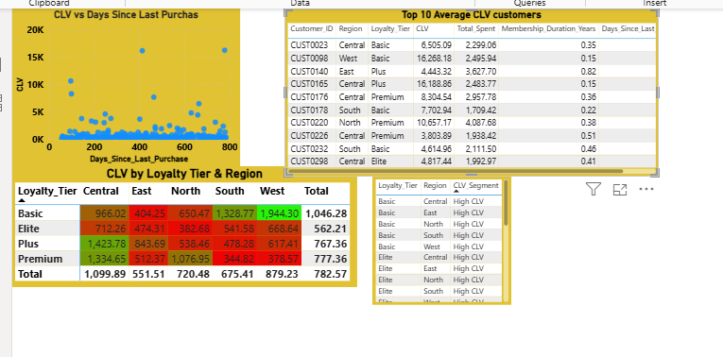

Insight and Recommendations

- The Top 10 CLV customers show very high lifetime values (₹4K–₹16K+ CLV), far above the average. These customers also appear across multiple tiers (Elite, Plus, Premium) and multiple regions.
- Some high-value customers show 200–600+ days since last purchase.
- Premium and Plus tiers have the highest CLV (₹777–₹1344 average across regions)
- North, West, and Central regions consistently have higher CLV.
- Focus especially on Central, West and South regions, where most High CLV customers appear.
- Many High CLV customers are still in Basic/Plus tiers. So need to Auto-upgrade high spenders and provide additional rewards for being active across months.
- Provide “Premium-only” benefits (free delivery, priority checkout, personal shopper support)

Task 7: Final Dashboard & Executive Summary (20 Marks)

Steps Used

1.Calculated New measure of Repeat Rate%
Repeat_Rate = DIVIDE( [Repeat Customers], [Total Customers], 0 )

2.Create New card and copy visual from task 1 and task 2 of below-

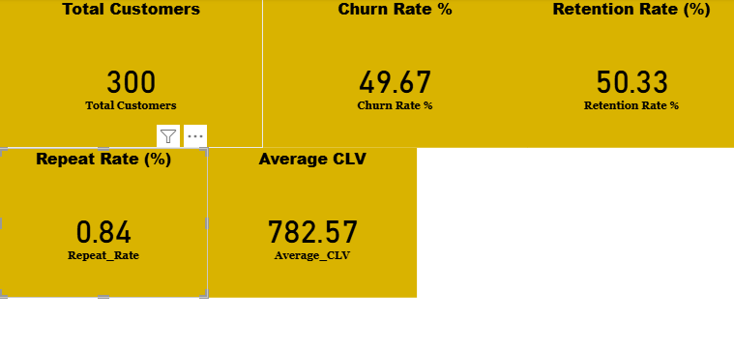

2.Copy same visual of task 4 and insert slicer based on region, income level, channel and loyalty tier.

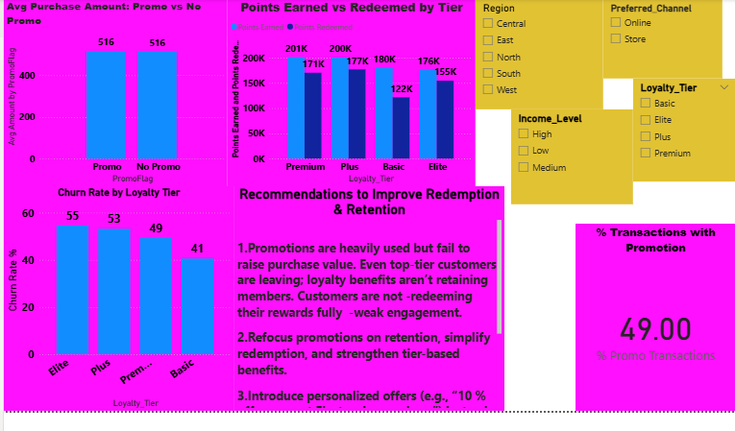

3.Copy the visual from task 5 and create a visual on basis of average clv and churn rate% by channel

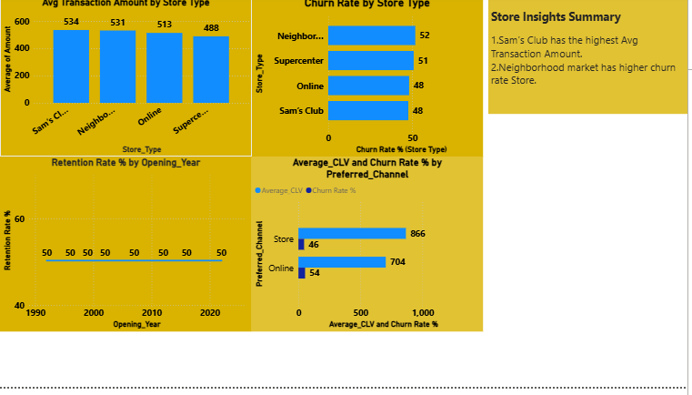
4.Create a visual based on Churned customer, repeat vs one time purchase, high value customer and insert slicer based on region, segment and loyalty tier

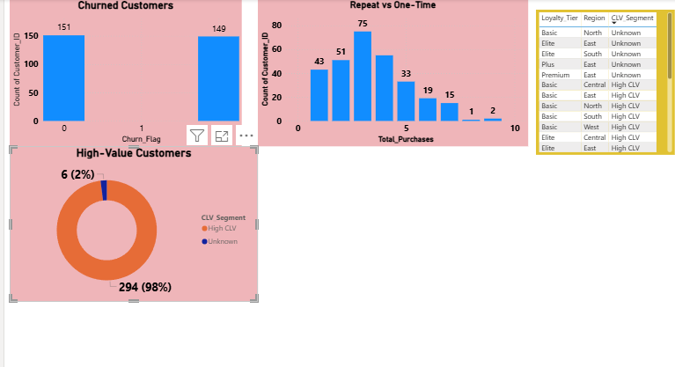
Top 3 recommendations for Walmart

- Which customers to prioritize for retention?
Walmart should primarily focus on High-Value Customers and Repeat Customers, especially those who show signs of declining engagement. Only 6 out of 300 customers (2%) are High CLV, yet they generate a large share of total revenue - these are extremely valuable.

- Which channels are underperforming?
The Online Channel is underperforming and needs improvement. Online customers have lower average CLV (₹704) compared to store customers (₹866).so need to Improve app/website experience and Reduce delivery time.

- How to strengthen loyalty program engagement?
Churn rates remain high even in Elite (55%) and Plus (53%) tiers → loyalty benefits aren't working well. Many customers appear as “Unknown” CLV Segment, meaning they aren’t fully integrated into the program.

- Make redemption easier & more visible.
- Exclusive offers for Elite and Premium.
- Priority checkout, free delivery, VIP access.
- Personalize rewards

